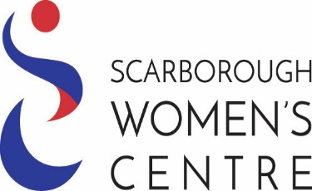



SCARBOROUGH WOMEN’S

CENTRE

ADDRESS:

2100

E

LLESMERE

R

OAD

,

SUITE

#245

PHONE:

416

-

439

-

7111

X

7

FAX:

416

-

439

-

6999

EMAIL: volcoord@scarboroughwomenscentre.ca

WEBSITE: www.scarboroughwomenscentre.ca



SCARBOROUGH WOMEN’S

CENTRE

**ONE TO ONE**

**PROGRAM**

INFORMATION FOR WOME

N SEEKINGSUPPORT

Scarborough Women’s Centre offers a one

-

to

-

one program for women in life transition who are

working towards specific goals. Each woman is matched with a

trained

volunteer and the pair

meets once a week. This

gives her another caring woman to talk to, someone to relate to and

someone to offer emotional support.

**SUPPORTIVE MENTORING**

For those who are coping with various life changes such as divorce, separation, a death in the

family, job loss,

or moving to a new city. Mentors assist women to build their support system,

break their isolation and be more in charge of their lives.

**ENGLISH CONVERSATION -**

**MENTORING/TUTORING**

For women who are new to Canada, or whose first language is not

English. Mentors assist women

who have already completed ESL or LINC training to further develop English conversation skills by

practicing in an informal, comfortable setting. Through conversations with her mentor a woman

is given the opportunity to improve her

English.

If you would like to receive this service, to arrange an interview or get further information,

please contact **Moulina, Coordinator of Volunteers at 416-439-7111 ext. 7**