- 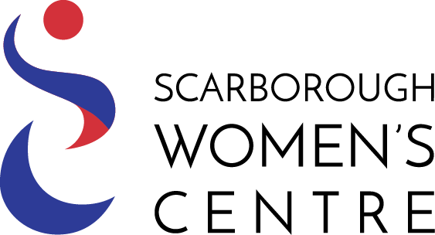  - INTRODUCING SCARBOROUGH WOMEN’S CENTRE  Our mission  Scarborough Women’s Centre empowers women to become economically and emotionally independent for future success and to strengthen their local communities free from violence. The Centre delivers programs and services to promote positive change for women in a safe, inclusive and welcoming environment.  Who we are  A non-profit, charitable organization (#10795-9660-RR0001), with a volunteer Board. Seven staff deliver services; ten facilitators offer courses and workshops; and seventy volunteers provide direct service or work on committees and events. Our work with women and their children has been recognized through the Mayor’s Community Safety Award. Our Executive Director received the 2013 City of Toronto Constance E. Hamilton Award on the status of women, and was recognized as an Ontario Leading Woman Building Strong Communities in 2016.  Who We Serve:  Women using the Centre are from all walks of life, economic situations, ethno-racial backgrounds and ages. Many are dealing with issues related to poverty, isolation, abuse, emotional health and newcomer integration. The majority are residents of Scarborough. We have touched the lives of 170,000 women and their children since our inception. |  | Our Programs and Services:  The Centre provides information, education and support services to assist women in the transition to economic and emotional independence. We also have the Building Strong Futures: Young Women’s Outreach and Expanding the Reach: Outreach to Women with Disabilities. All these programs support women to develop life skills, support networks, and self-confidence to achieve their goals for economic and emotional independence, free of violence.  The Impact Of Our Programs And Services:  Women benefit from the experience of learning with others. They realize that they are not alone, that they have options in their lives, and that they deserve to live free of fear. In 2021-22, the Centre served 3000 women and girls.  Typically, women will report the following outcomes after using our services  - Leave an abusive situation, develop a safety plan  - Register for further training (community college, GED, etc.)  - Obtain employment, build marketable skills, improve work performance job  - Build self-confidence, solve personal problems
Ways you can get involved:
- Participate in events to raise funds to provide supportive services to women
- Tell women you think could benefit from services at the Centre
- Consider volunteering as a mentor, tutor or workshop host
Thank you for your interest! With your support, women can make a brighter future for themselves and their children!

HERE ARE SOME STORIES FROM WOMEN WHO HAVE USED THE SERVICES AT SCARBOROUGH WOMEN’S CENTRE. THEIR NAMES HAVE BEEN CHANGED TO PROTECT PRIVACY.

Nneka

I was raised in a small village. At the age of 14, my father offered me to the village elder to be his fourth wife. I ran away with a man who made me many promises and took me away to Europe. Once there, I was forced to work as a prostitute.

I was able to escape and made my way to Canada with the help of a group who referred me to Scarborough Women’s Centre. Thanks to the counselling services, I was able to deal with the trauma of abuse and turn my life around. I recently obtained my GED and plan to attend college in the fall…

Rose

I got married at 19, and give birth to my first of four children by the time I turned 20. At the beginning of my marriage, I believed my husband to be loving and attentive – he wouldn’t let me work and made me feel special by calling me every hour to check in on me. Then, he started calling me stupid. We began to face increasing difficulties and he eventually began an affair with our neighbour and walked away from me and the children.

Scarborough Women’s Centre helped me get immediate financial support for my children and provided my children and me with access to programs to get us back on our feet and economically and emotionally independent. Thanks to the support of the SWC, I have just graduated as an RNA from Centennial College…

Marianne

I have lived with a disability all my life which limits my mobility. I live alone and am estranged from my family. I have spent a great part of my life feeling very isolated. Scarborough Women’s Centre has given me a new lease on life. I have enjoyed participating in many of the programs and leadership development workshops and as a bonus, have developed a strong social support network for myself. I am now becoming more active in the community and have learned about what it means to advocate for myself and support other women living with disabilities…

2100 Ellesmere Road, Suite 245 * Scarborough, Ontario M1H 3B7 * Tel: 416-439-7111 * Fax: 416-439-6999

